KRATIN ASSIGNMENT SOLUTION

Q. How can you help Sunita Sharma (65+ years old) to live a healthier and better life?

ANS.

Step 1 We can help the elderly people in many ways like we can make an application which will connect the user to the doctor who will prescribe the patient healthy chart which will describes all the activities that must be perform by the user so as to live in a healthy lifestyle. Step 2 We can connect various elderly people through the application so that they can form a group and can share similar lifestyle. We can also provide an to-do list with alarm which will reminder the user to set time for the respective activity and will check the list so that user cannot get confused. We can add a lot of features so that it can help the people to live healthy

ALSO PROVIDE A 1:1 DOCTOR CONSULTANT FOR BETTER HELP OF EACH INDIVIDUAL AND TRACK THEIR PROGRESS.

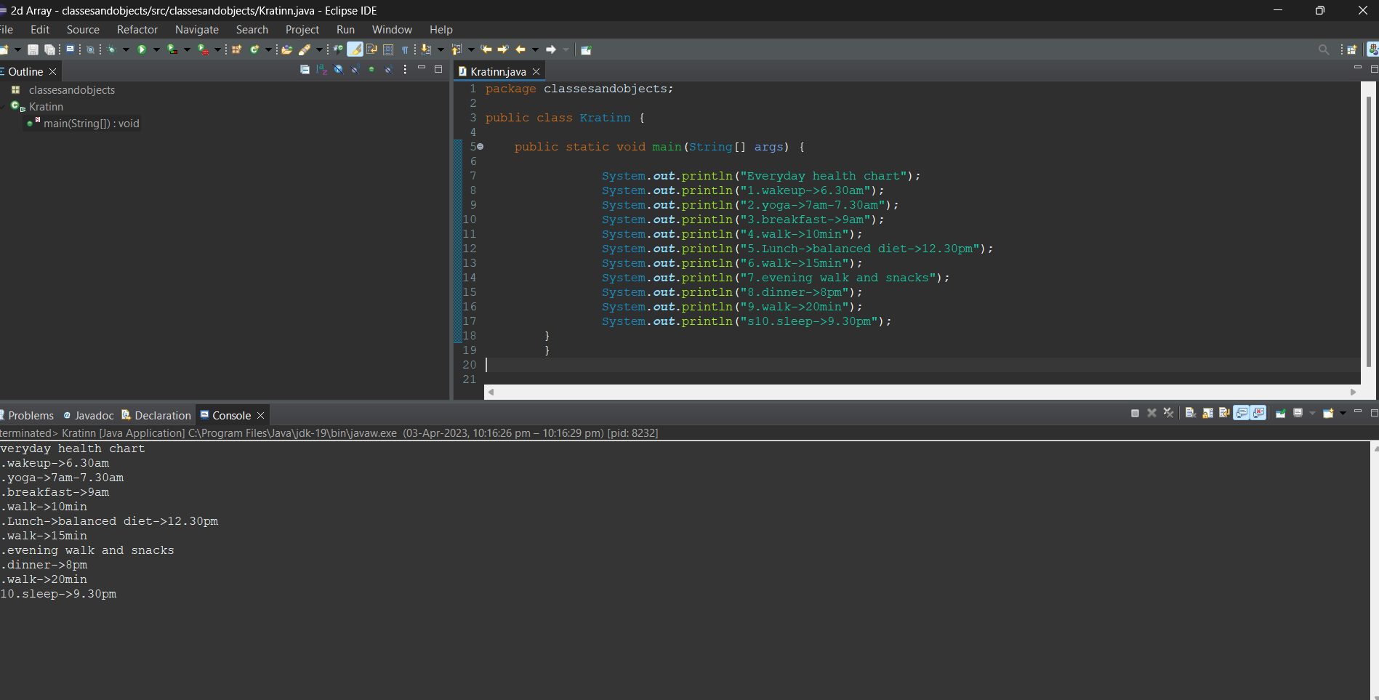

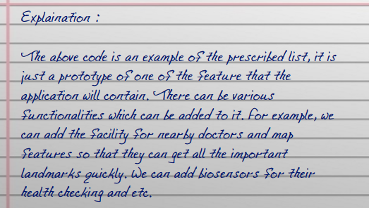

A BENEFIT OF 1:1 CONSULTANCY WILL PROVIDE A MAJOR IMPACT ON HEALTH OF PEOPLE AND CAN INCREASE THEIR CHANCES TO LIVE HEALTHEIR LIFE MORE YEARS…..